Regarding communication channel progress, Mr. Elik constructed a filter bank which will be used at the FM radio output. This filter bank will be used as channel selector. Each band (channel) will be mapped into a certain command. The designed filters in LTSPice can be shown in figure XX. The filter bank is contructed to have 10 bands. However, for the demo, only two of them will be used.

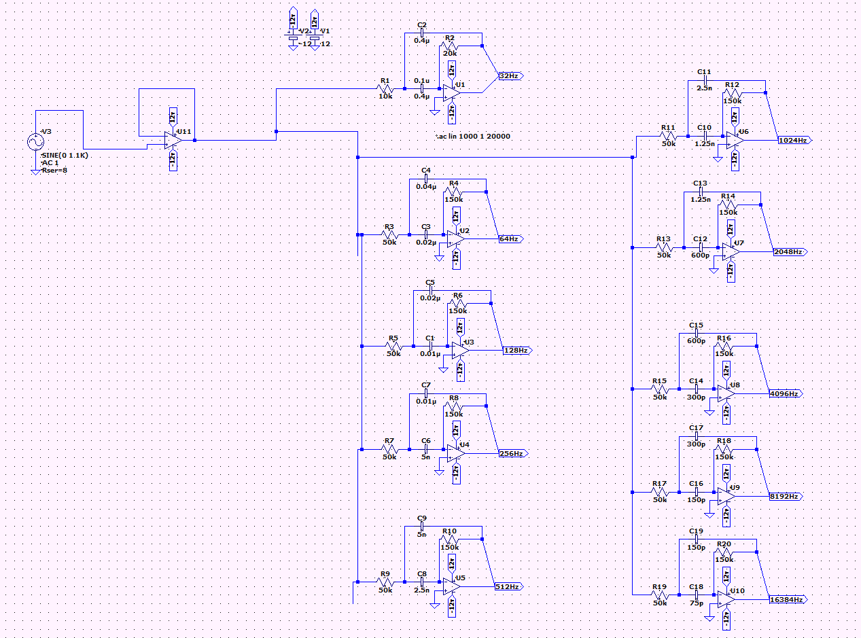

Figure 1 Circuit schematic of the filter bank

The frequency response of the filter can be seen in figure XX.

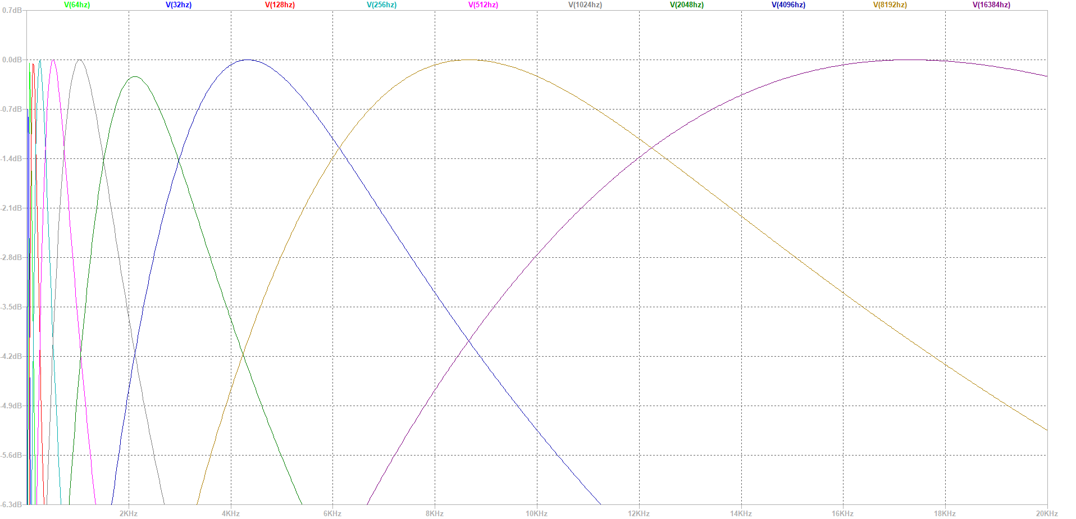

Figure 2 Frequency Response of the filters

What baho will do in next week:

At least two band pass filters will be implemented and tested.